stpilogon

**NSTP Unit Renewal application**

**General Instructions:**

**Step1:** Fill about Company, Directors Detail, Bank Details, Capital, Investment, Project Exports, Manpower and other details.

**Step2:** Upload all mandatory documents.

**Step3:** Download application form and Sign it. Upload scanned copy of Renewal Application Form.

1. **Click on LOP/LUT--> Renewal of Lop from side bar menu**

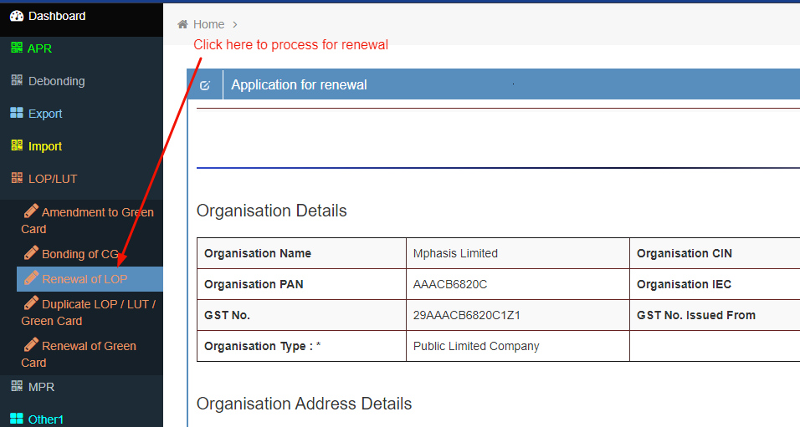

1. **Enter Company details and click on Save button.**

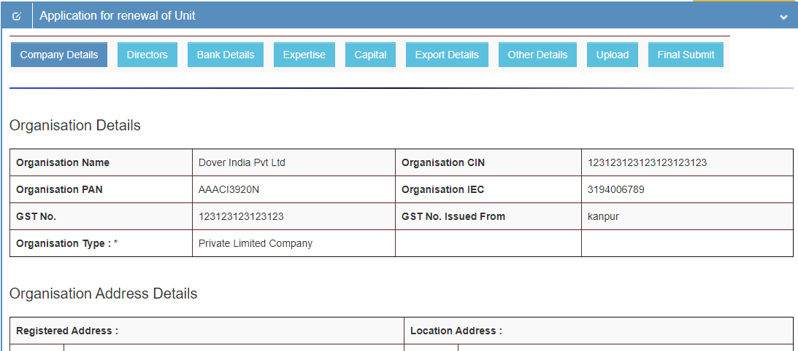

1. **Click on Directors Menu , Enter Directors details and click on save button.**

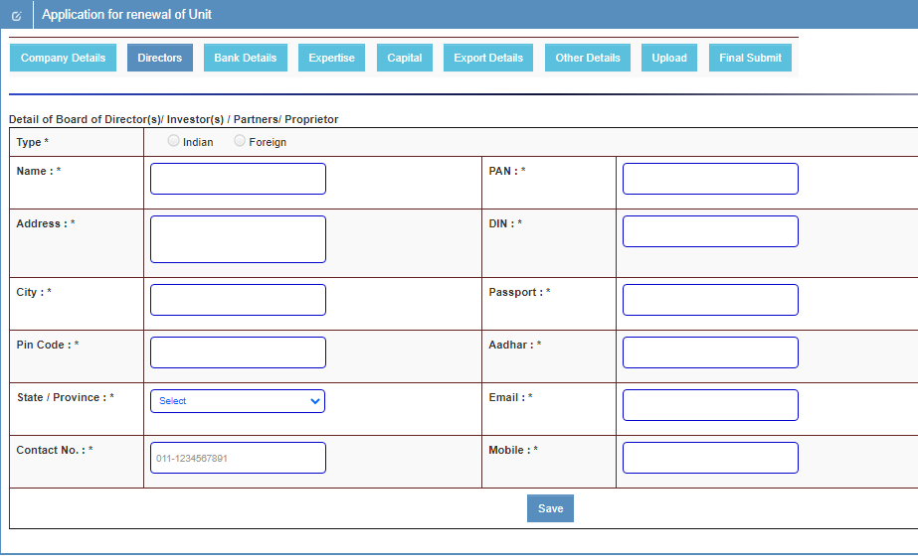

1. **Click on Bank Details menu.**

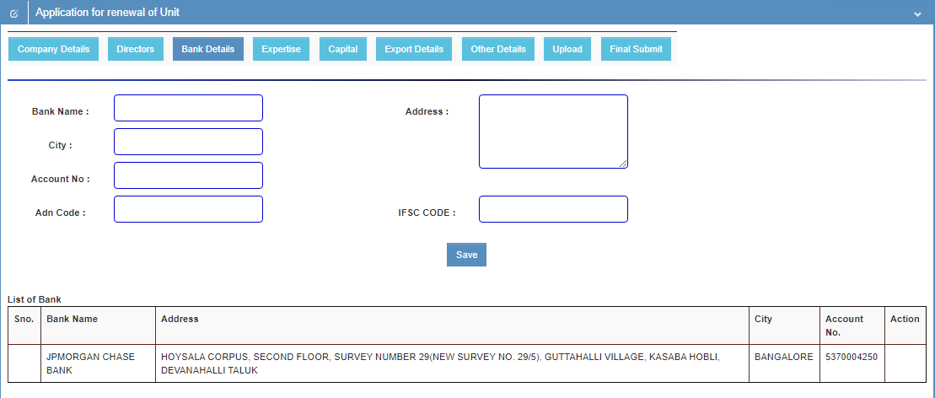

1. **Click on Expertise menu, Enter all details then click on save button**

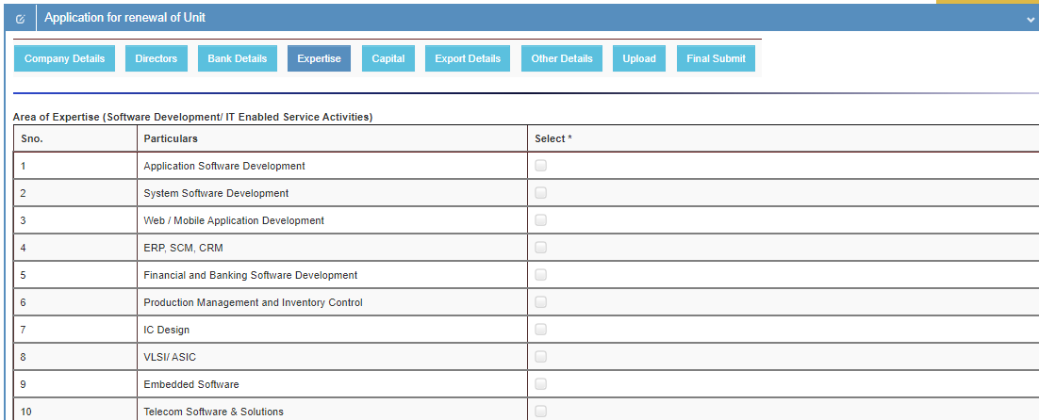

1. **Click on Capital menu, enter all details and click on save button.**

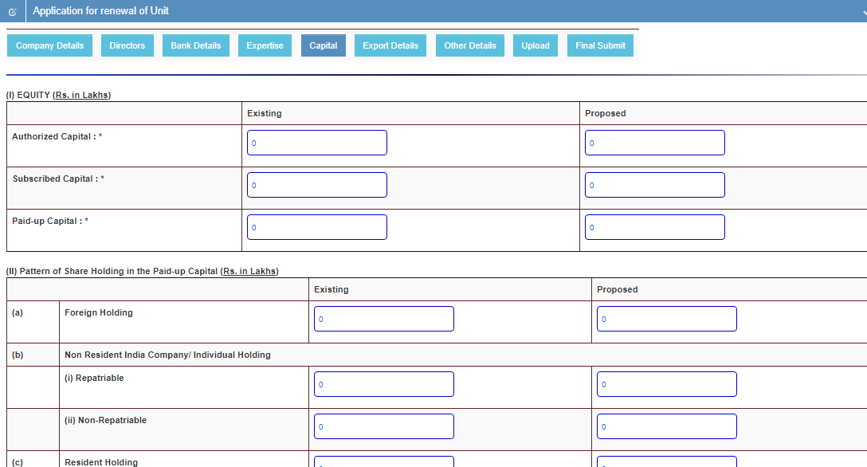

1. **Click on Export Details menu, Enter all details and click on save button**

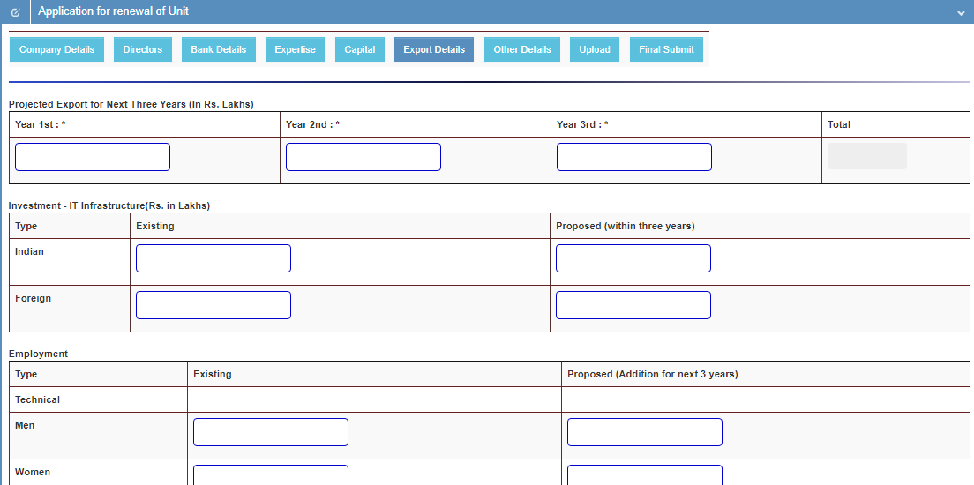

1. **Click on Other Details menu, Enter all details and click on save button**

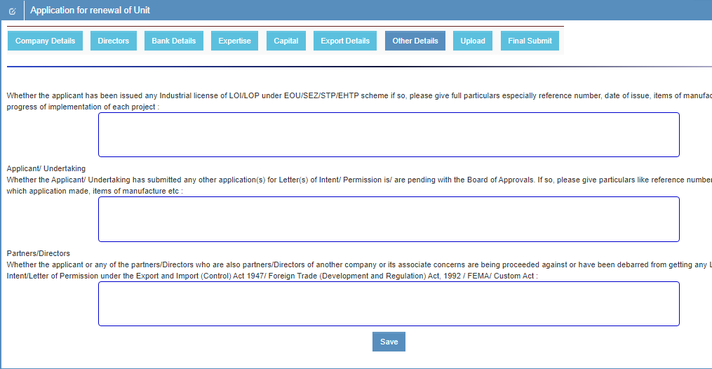

1. **Click on upload menu, Select (.pdf ) file of require documents and upload one by one**

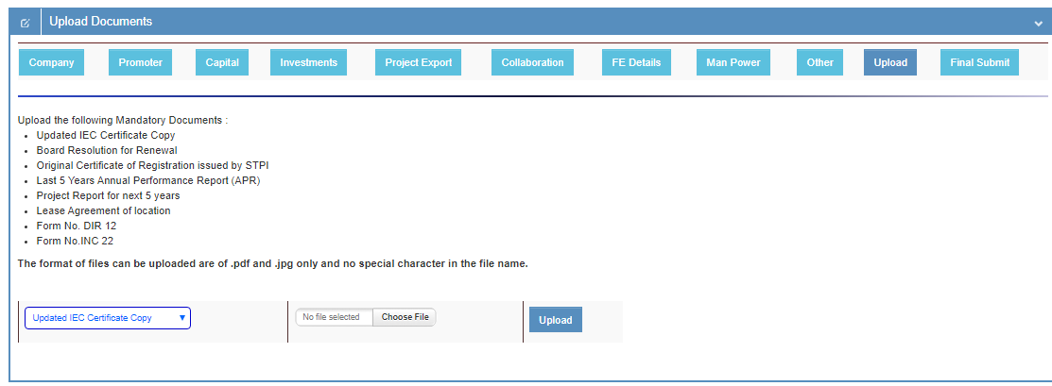

1. **Click on final submit menu, click on download application form button.**

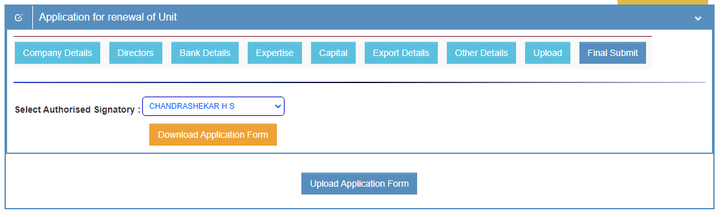

1. **After download application form signature & seal on each page then click on upload button.**

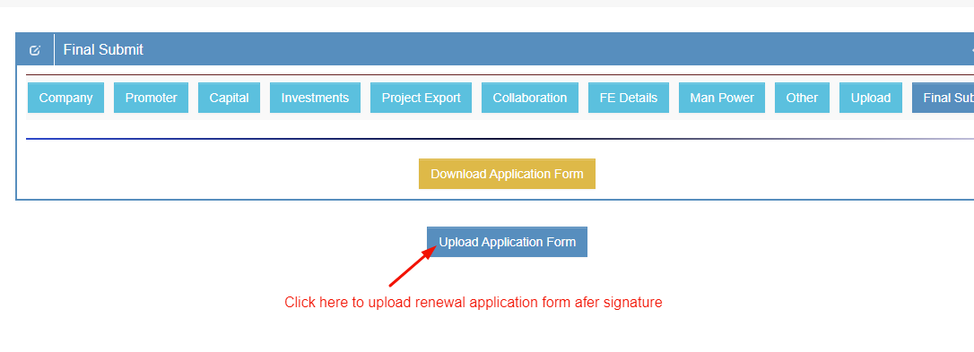

1. **Upload singed application form (.pdf ) type then click on final submit button.**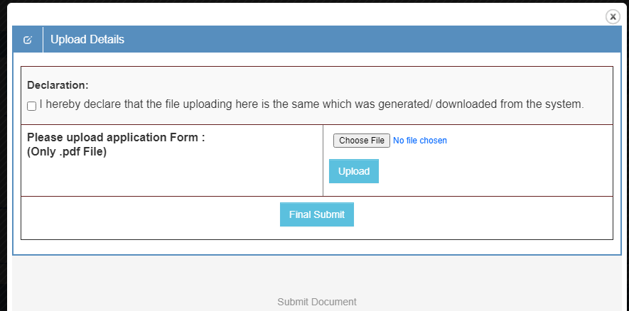
2. **Now status is showing Pending.**

